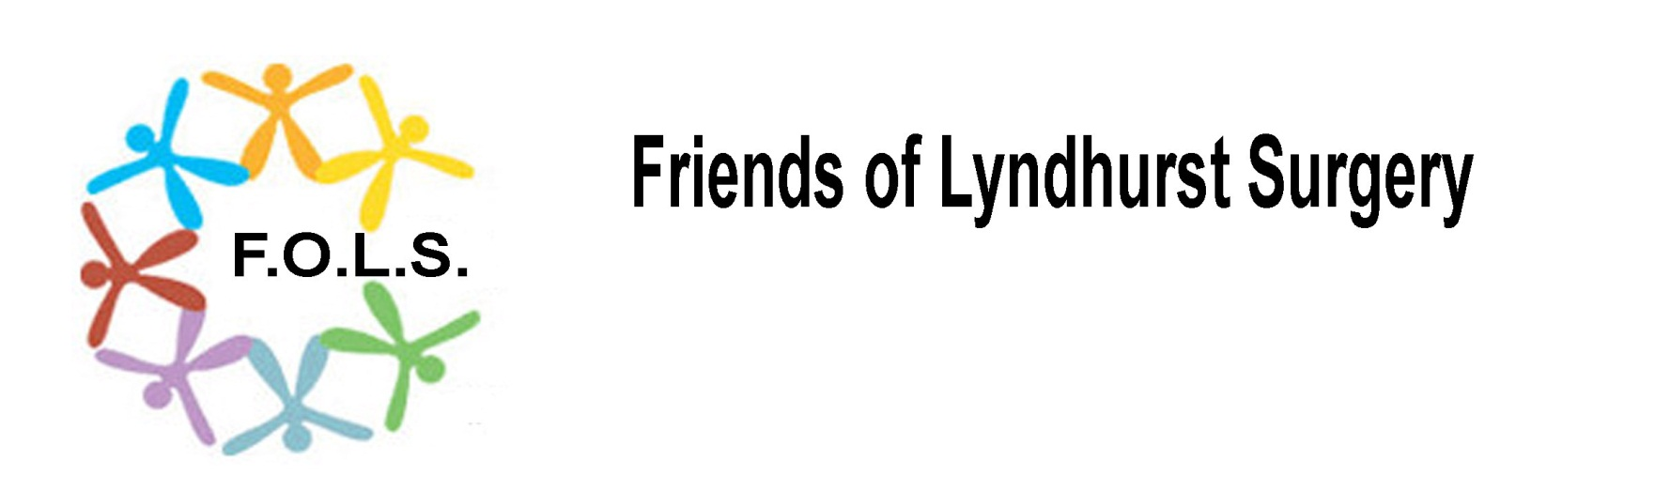

Gift Aid Declaration
Name of Charity: Friends of Lyndhurst Surgery
Charity Registration Number: 1014905

Please treat any gifts of money that I have made since date: ……………………………. and any gifts that I make in the future as Gift Aid donations.

Title: ……….Initial(s): …………………… Surname: ……………….
Home address: …………………………………………………………………………………………………………
Post code: ……………………………….
Date: _________________________________

Signature: _____________________________
Notes
You must pay an amount of Income Tax and/or Capital Gains Tax for each tax year that is at least equal to the amount of tax that the charity will reclaim on your gifts for that tax year. The charity will reclaim 25p on tax on every £1 you give. If you pay income tax at the higher rate, you must include all your Gift Aid donations on your Self Assessment tax return if you want to receive the additional tax relief due to you.

Please contact the charity if you (i) want to cancel this declaration; (ii) you change your name or address; (iii) if you no longer pay sufficient tax on your income/capital gains.

